***PRESS RELEASE***  
For Immediate Release

|  |
| --- |
| Zojirushi’s Mr. Bento® - Make a Bold & Brilliant Statement of Taste at Lunchtime  cid:image016.jpg@01D476BD.BDDED1A0cid:image017.jpg@01D476BD.BDDED1A0cid:image015.jpg@01D476BD.BDDED1A0cid:image018.jpg@01D476BD.BDDED1A0 |

Chicago, IL (March 2, 2019) – Be the envy of the lunchroom with *Mr. Bento® -* Zojirushi’s best-selling lunch jar, now available in brilliant new colors. Comprised of a vacuum insulated outer container, four microwaveable inner containers, a forked spoon, and tote, *Mr. Bento®* is the perfect option for carrying hot or cold food items to school or work. With Zojirushi’s 5-year warranty on heat retention, users can rest assured that this product will keep foods at optimal temperatures. The *Mr. Bento*® Stainless Lunch Jar SL-JBE14 comes in 4 colors, Blueberry, Plum, Carbon Black, and Stainless. Mr. Bento will carry a suggested retail price of $68.00, and will be available in April 2019.

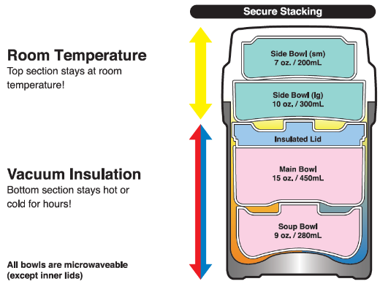*Mr. Bento®* comes complete with 4 microwaveable inner bowls (9 oz. soup bowl, 15 oz. main bowl, 10 oz. and 7 oz. side bowls), with a total 41 oz. capacity. The soup and main bowls stack neatly in the outer container for insulation, and the two side bowls stack on top. The outer lid snaps close to keep all bowls contained for easy transport. A gasket on the soup bowl lid helps to minimize leaks, and a pressure release valve allows it to be opened easily even when pressure builds up inside. Made of durable stainless steel, the outer container features Zojirushi’s superior insulation technology, keeping foods warm or cold for about 6 hours, and is nonstick coated inside, making it easy to clean. All areas that come into contact with food are BPA free, ensuring the safety of your meal.

**About Zojirushi**

In 2018, Zojirushi celebrated its 100th anniversary, and a century of products designed to improve customers' quality of life—bringing comfort, ease, vitality and affluence to people around the world. Zojirushi was established in 1918 as a producer of hand-blown vacuum bottles and has been a world leader in thermal products ever since. The Zojirushi line was expanded to include a wide range of stainless steel vacuum bottles, rice cookers, breadmakers, *Air Pot*® beverage dispensers, thermal serving carafes, specialty cookware, small electrics, restaurant equipment, and other products. Striving to remain faithful to the principles that embodied the company's first 100 years, and the reputation of quality and durability it earned them, Zojirushi looks forward to a future of continued innovation and inspired design.

For more information on the entire quality Zojirushi Product Collection, contact Zojirushi America Corporation at 800.733.6270 or visit www.zojirushi.com

On Facebook: http://www.facebook.com/zojirushiusa

On Twitter: @ZojirushiUSA

On Instagram: @zojirushiamerica

# # #

For More Information:

Krista Erickson

[pr@zojirushi.com](mailto:pr@zojirushi.com)

310.926.1435