Press Release
Media Contact:
Productivity PR, Inc (818) 223-9046 info@productivitypr.com
Stop Wasting Wine and
Enjoy One Glass at Time with ZOS

ZOS Wine Preserver is the only system that removes 100% of the oxygen of an opened bottle of wine so that it can be enjoyed for weeks…or even months
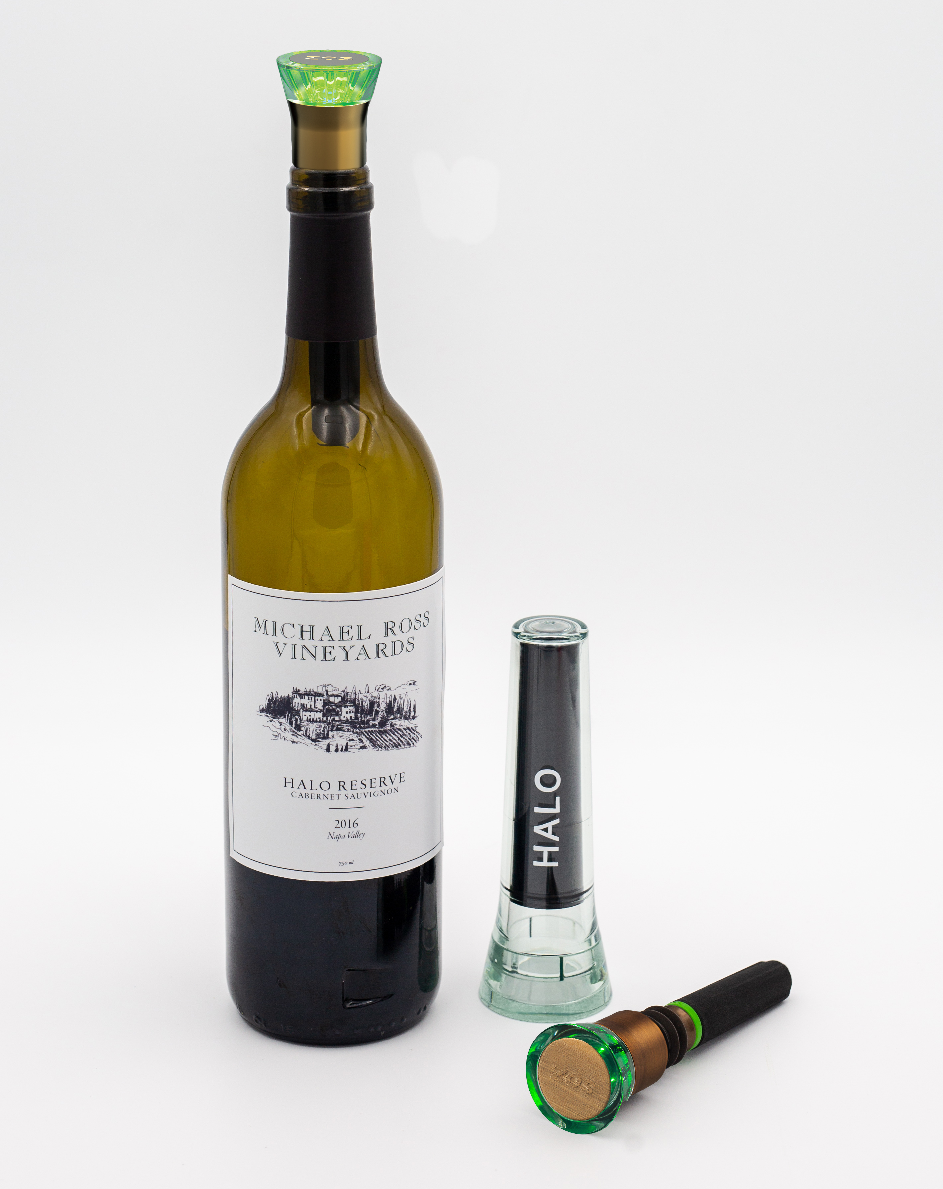
Santa Rosa, CA – It is estimated that the average American drinks at least a few glasses of wine per week but more than $1.5 billion of opened wine is still poured down the drain each year because of spoilage. However, it’s not a surprising statistic considering that wine is typically purchased by the bottle but consumed by the glass. But what if you didn’t have to pour your favorite wine down the drain when you don’t finish the bottle? Zero Oxygen Solutions, the makers of the ZOS Halo, have perfected the science of wine preservation. ZOS is the first and only system that removes 100% of the oxygen that damages wine so that an opened bottle can be preserved for up to two months or more.

As soon as a bottle of wine is opened, it is exposed to air and begins to oxidize and will change taste within a couple hours and spoil within a day or two. To preserve wine, it is critical to remove 100% of the oxygen. In fact, even one percent of oxygen can damage wine significantly. Other wine preservation methods such argon gas don’t remove oxygen from the bottle and vacuum pumps (after hundreds of pumps) leave a very significant amount of oxygen in the bottle thus limiting the amount of time a bottle of wine can be enjoyed. ZOS is the only solution that removes 100% of the oxygen so that an opened bottle of wine tastes and smells the same weeks, or months later as it did when it was last opened.

ZOS is easy to use. Simply insert the ZOS stopper with the reusable, oxygen-absorbing cartridge and within minutes it will absorb 100% of the oxygen from the air remaining in the bottle Cartridges last about 15 bottles depending on oxygen exposure. ZOS also features an electronic cartridge tester that tells you within seconds if the cartridge it still good (green) or needs to be replaced (red).

“ZOS is ideal for anyone who wants to open a bottle for just a glass, or keep more than one bottle open at a time,” says ZOS founder, Greg Luzaich. “With ZOS, you can enjoy what you want, when you want, and finish a bottle at your own pace without worrying about pouring wine down the drain.”

The ZOS wine preservation kit includes: one reusable oxygen absorbing cartridge, one electronic stopper and a testing holder. $74.95 MSRP. Replacement cartridges and additional bottle stoppers sold separately.

About Zero Oxygen Solutions
Developed by a team of engineers and wine enthusiasts with over 20 years of experience in wine preservation technology, ZOS is the only wine saver that removes 100% of the oxygen that spoils wine. ZOS’s proprietary technology is the result of a four-year research and development effort. For more information, please visit www.zoswine.com

###

